

North Florida School of Aikido (North Florida Aikikai)

is proud to present
A Seminar
with Tim Magill Sensei
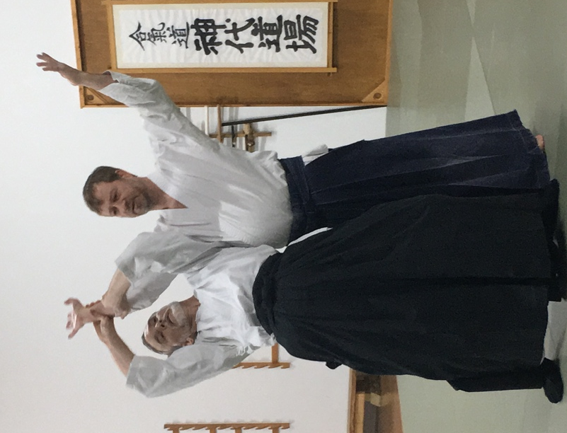
Tim Magill Sensei is a rokudan (6th dan) in Aikido. He has been studying Aikido since 1986 and has been influenced by many great teachers, including Saotome Shihan, Frank Doran Shihan, John Messores Sensei and Mary Heiny Sensei.

Magill Sensei joined Shindai Dojo in 2014. He has trained and taught extensively throughout the United States and abroad.

Dates: December 5-7, 2026 Cost: $100

Class Times: Friday, 6:30pm – 8:30pm
Saturday, 10:00am – 12:00pm and 2:30pm – 4:30pm
Sunday, 10:00am – 12:00pm

Location For information
North Florida School of Aikido Call Richard Moore
1535-1 Capital Circle NW (850) 528-7666 or Email
Tallahassee, FL 32303 info@northfloridaaikido.org


